Genetic Disorder



**A genetic disorder is a disease that is caused by a change, or mutation, in an individual’s DNA sequence.**

**These mutations can be due to an error in DNA replication or due to environmental factors, such as cigarette smoke and exposure to radiation, which cause changes in the DNA sequence.**

**when a section of our DNA is changed in some way, the protein it codes for is also affected and may no longer be able to carry out its normal function.**

**Depending on where these mutations occur, they can have little or no effect, or may profoundly alter the biology of cells in our body, resulting in a genetic disorder.**

**Genetic disorders categories:**

1. **Single gene disorders: disorders caused by defects in one particular gene, often with simple and predictable inheritance patterns.**

**For example: Dominant diseases**

* **Chromosome disorders: disorders resulting from changes in the number or structure of the chromosome for example: Down’s syndrome**
* **Multifactorial disorders (complex diseases): disorders caused by changes in multiple genes, often in a complex interaction with environmental and lifestyle factors such as diet or cigarette smoke.  For example, cancer?**



**How are genetic conditions diagnosed?**

**A doctor may suspect a diagnosis of a genetic condition on the basis of a person’s physical characteristics and family history, or on the results of a screening test.**

**Genetic testing is one of several tools that doctors use to diagnose genetic conditions. The approaches to making a genetic diagnosis include:**

* **A physical examination: Certain physical characteristics, such as distinctive facial features, can suggest the diagnosis of a genetic disorder.**
* **Personal medical history: Information about an individual’s health, often going back to birth, can provide clues to a genetic diagnosis.**
* **Family medical history: Because genetic conditions often run-in families, information about the health of family members can be a critical tool for diagnosing these disorders.**
* **Laboratory tests, including genetic testing: Molecular, chromosomal, and biochemical genetic testing are used to diagnose genetic disorders.**

**Genetic testing is currently available for many genetic conditions. However, some conditions do not have a genetic test; either the genetic cause of the condition is unknown or a test has not yet been developed.**

**A diagnosis of a genetic disorder can be made anytime during life, from before birth to old age, depending on when the features of the condition appear and the availability of testing.**

**Sometimes, having a diagnosis can guide treatment and management decisions.**

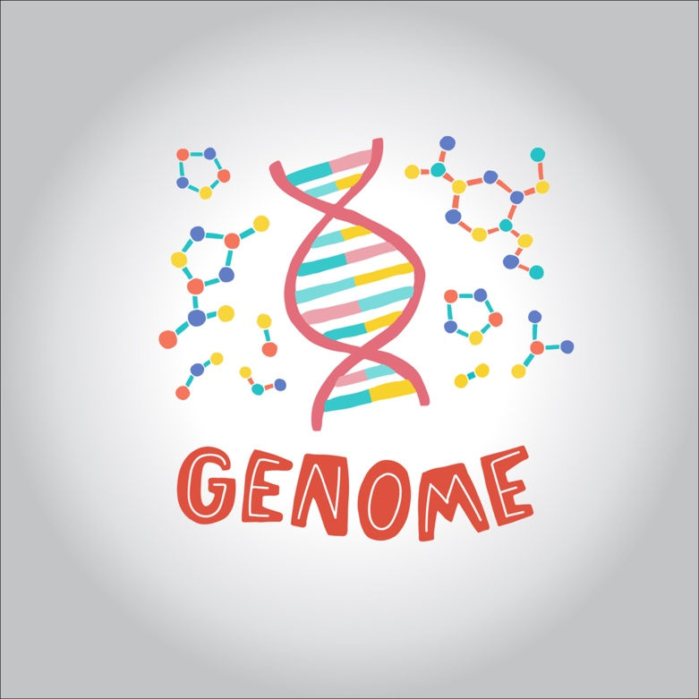

**How are genetic conditions treated or managed?**

**Most cannot be cured. However, approaches may be available to treat or manage some of the associated signs and symptoms.**

**For a group of genetic conditions called inborn errors of metabolism, treatments sometimes include dietary changes or replacement of the particular enzyme that is missing. Limiting certain substances in the diet can help, In some cases, enzyme replacement therapy can help compensate for the enzyme shortage.**

**These treatments are used to manage existing signs and symptoms and may help prevent future complications.**

**Bone marrow transplantation (BMT) is the only known treatment for a variety of genetic diseases sometimes called “inborn errors of metabolism” or “storage diseases.” These diseases are caused by a deficiency of a specific substance in the body, usually a protein, which results in the accumulation of toxic chemicals inside the cells.**

**Depending upon the protein abnormality and the chemicals that accumulate, specific patterns of tissue damage and organ failure occur, including:**

* **Central nervous system deterioration**
* **Growth failure**
* **Bone abnormalities and joint disability**
* **Enlargement of the liver and spleen in the abdomen**
* **Heart disease**
* **Airway obstruction**
* **Lung disease**
* **Corneal clouding**
* **Hearing loss**

**The eventual organ damage and outcome of the different diseases is quite variable, although the ones in which BMT has been evaluated are those that have a naturally progressive downward course usually ending in death during childhood.**

**Despite this, most treatment options revolve around treating the symptoms of the disorders in an attempt to improve patient quality of life.**

**Symptoms:**

* **Ear abnormalities**
* **Unusually shaped eyes**
* **Different colored eyes**
* **Facial features that are unusual or different from other family members**
* **Brittle or sparse hair**
* **Excessive body hair**
* **White patches of hair**
* **Large or small tongue**
* **Misshapen teeth**
* **Missing or extra teeth**
* **Loose or stiff joints**
* **Unusually tall or short stature**
* **Webbed fingers or toes**
* **Excessive skin**
* **Unusual birthmarks**
* **Increased or decreased sweating**
* **Unusual body odor**

**Genetic disorder by Age**

**It was found that, before approximately age 25 years, greater than or equal to 53/1,000 live-born individuals can be expected to have diseases with an important genetic component.**